PetHaven Data Solution — Work Log, 20 Sep 2026
Sep 20, 2026 ·
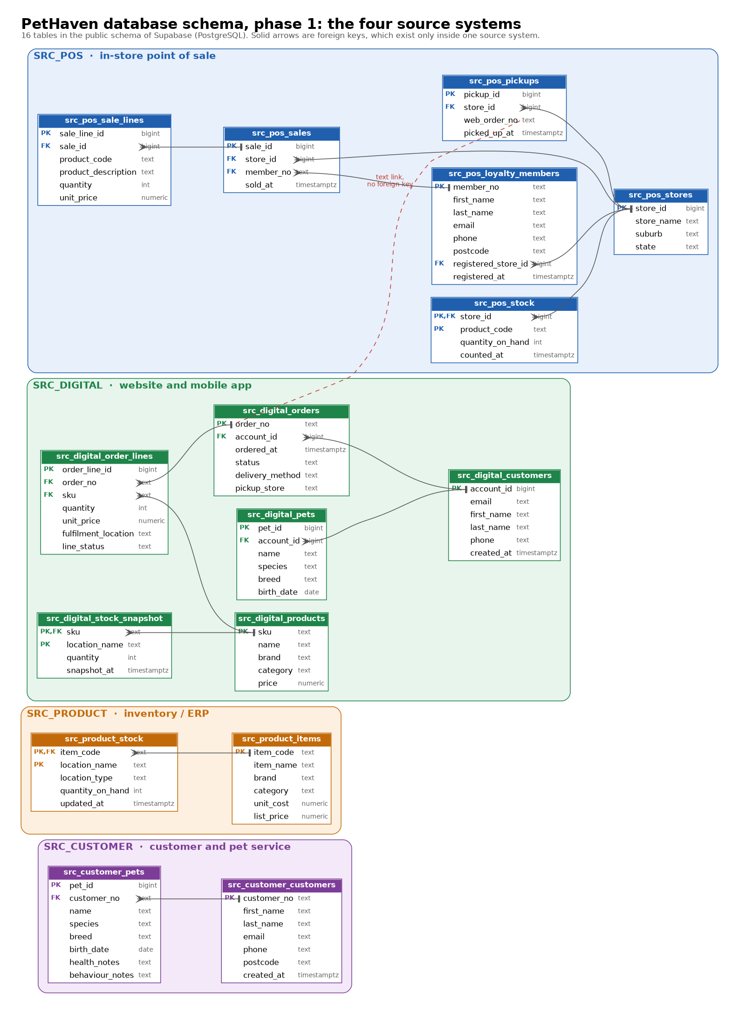

Project setup and security
The repo is set up so teammates can reproduce the environment and no secret can reach GitHub. The stack is Python scripts written in VS Code, Supabase as the database, and GitHub for the code.
File or folder | Purpose
.gitignore | Blocks .env, .venv and the contents of data/ (may hold personal data); keeps the folder structure
.env.example | Template of required variables: SUPABASE_URL, SUPABASE_SECRET_KEY, DATABASE_URL
requirements.txt | Pinned dependencies: supabase 2.31.0, python-dotenv 1.2.1, psycopg[binary] 3.3.6
.vscode/ | Recommended Python extensions; VS Code reads .env
src/db.py | Supabase client that reads credentials from environment variables
scripts/test_connection.py | Checks the credentials and that a table exists
scripts/apply_schema.py | Applies db/schema.sql in one transaction (see the runbook below)
db/schema.sql | The database structure, kept as the single source of truth; the current 33-table version is being replaced to match the agreed architecture
data/raw, cleaned, processed; notebooks; docs; tests | Folder structure from the README, kept with .gitkeep files
README.md | Setup steps; the team rewrote it during the day, and the schema section was added to that version
Security rules agreed for the project:
- .env is never committed; only .env.example is.
- SUPABASE_SECRET_KEY bypasses Row Level Security (RLS), so it is used only in local or server-side scripts.
- Every table has RLS enabled with no policies, so only the secret key can read or write.
- A leaked key is rotated in Supabase (Settings, API Keys); deleting it from git history is not enough.
- Recommended on GitHub: secret scanning, push protection, and pull requests into main.
- Teammates are invited to the Supabase project and copy keys themselves, never through chat.
One housekeeping note: a git status run during setup left a stale .git/index.lock. It was removed, together with a test file, after delete permission was granted, and git works normally.

Data source design
The four sources changed from POS, Digital, ERP and Grooming to POS, Digital, Product and Customer, so the data centres on pet retail: customers, products and pets. The new names also line up with the systems in the Assignment 1 report.
Source | Change | Holds
SRC_POS | Kept | In-store transactions, local stock, loyalty registrations, click and collect pickups
SRC_DIGITAL | Kept | Web and app orders, customer accounts, pet profiles, product catalogue, overnight stock copy
SRC_PRODUCT | Replaces SRC_ERP | Items, suppliers, central and distribution centre stock
SRC_CUSTOMER | Replaces SRC_GROOMING | Customers, pets with health and behaviour notes, grooming bookings

Agreed implementation architecture
The first schema draft (33 tables) followed the full Assignment 1 solution, which may be too large to implement. The team agreed a smaller architecture with five stages: sources, staging, integration and MDM, a dimensional data warehouse, and reports. It is scoped to three use cases from Table 4 of the Assignment 1 report: UC1 customer and pet profile, UC2 inventory visibility and UC4 order and shipment traceability. The other use cases (UC3, UC5 and UC6) are out of scope for this phase.
The data fabric, graph model and data vault layer from the report are not included. The report describes PetHaven as a fictional Australian retailer with 30 Sydney stores, 1 distribution centre, 10,000 SKUs and 300,000 customer records, of which 30,000 are duplicates. The decisions on the open questions of the previous version of this record, and the resulting changes, are listed below the tables.
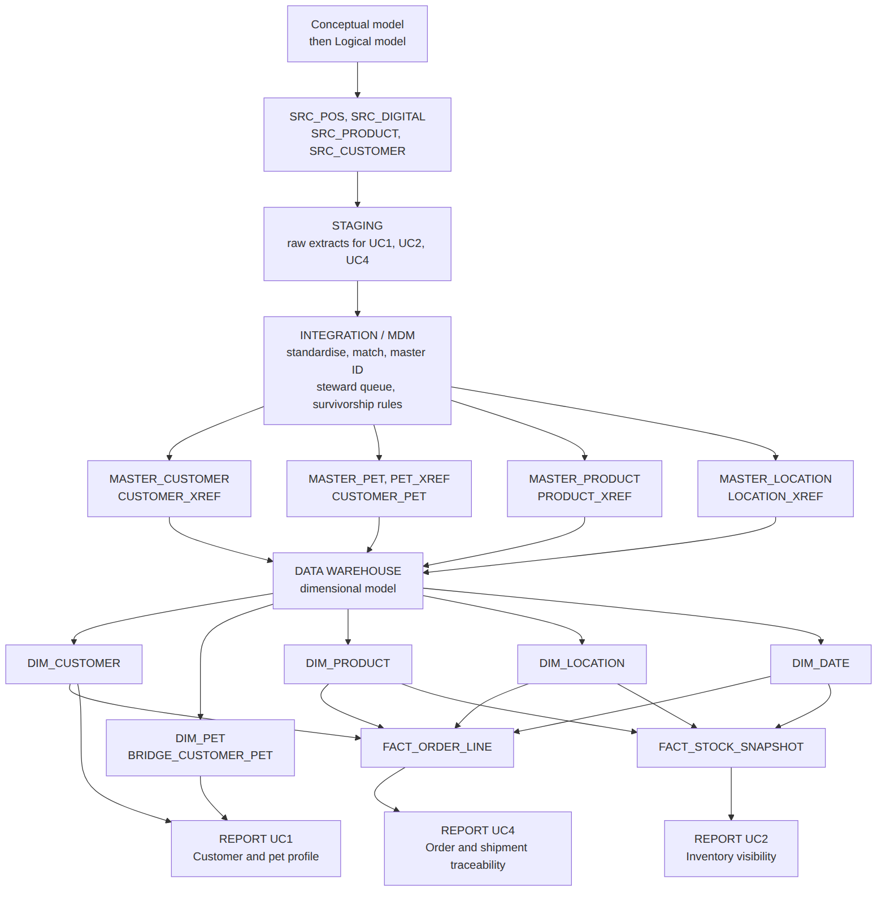
Each stage reads only from the one before it, and reports read only from the warehouse. Source records are copied unchanged into staging; the integration layer maps each source key to one master ID through the cross-reference (XREF) tables, following the registry approach the report recommends; and the warehouse is built from the master data. db/schema.sql currently holds only the source layer (the 16 tables in the schema diagram at the top of this record); the layers below it are added in later steps.

Stage | What happens, and which objects
Sources | The four systems stay as they are: SRC_POS, SRC_DIGITAL, SRC_PRODUCT, SRC_CUSTOMER
Staging | Raw copy of each source extract needed by UC1, UC2 and UC4 (customers, pets, products, locations, order lines, stock), with no cleaning. Each row keeps its source system, batch and load time. Table list decided in the schema rewrite
Integration / MDM | Standardise, match and assign a master ID: MASTER_CUSTOMER and CUSTOMER_XREF, MASTER_PET and PET_XREF, CUSTOMER_PET (many-to-many link), MASTER_PRODUCT and PRODUCT_XREF, MASTER_LOCATION and LOCATION_XREF; MATCH_CANDIDATE (steward review queue) and SURVIVORSHIP_RULE
Data warehouse | Dimensional model: DIM_CUSTOMER, DIM_PET, BRIDGE_CUSTOMER_PET, DIM_PRODUCT, DIM_LOCATION, DIM_DATE; facts FACT_ORDER_LINE and FACT_STOCK_SNAPSHOT
Reports / dashboards | Answer three use cases: UC1 customer and pet profile, UC2 inventory visibility, UC4 order and shipment traceability

How the schema responds to the problems in the report. Only the three use cases in scope are shown (UC1, UC2 and UC4 from Table 4 of the Assignment 1 report), with their related problems P1, P2 and P4. P3, P5 and the use cases UC3, UC5 and UC6 are out of scope for this phase.
Problem in the report | Use case (Assignment 1 report) | DB solution | Schema response
P1 Fragmented customer data | UC1 Customer and pet profile  Link customer records across POS, digital channel and grooming system, and keep pet profiles linked to the customer record so services can reuse them | Registry-style MDM: source records stay where they are, and a cross-reference table maps each source customer ID to one master ID. Customers and pets are linked many-to-many. High-confidence matches link automatically, middle-band matches go to a steward, and the rules lean towards under-merging. | Staging customer and pet extracts; MASTER_CUSTOMER, CUSTOMER_XREF, MASTER_PET, PET_XREF, CUSTOMER_PET, MATCH_CANDIDATE, SURVIVORSHIP_RULE; DIM_CUSTOMER, DIM_PET, BRIDGE_CUSTOMER_PET (UC1)
P2 Inventory desynchronisation | UC2 Inventory visibility  Provide current store and DC stock information before an online or Click and Collect order is confirmed, and allow stock enquiry across locations | Bring the stock figures of every system into one table keyed by master product and location, each with its snapshot time, so figures can be compared and the freshest one chosen. The product and location cross-reference tables give every system's code one master ID. Live synchronisation (the report's data fabric) stays outside the database. | Staging stock extracts; MASTER_PRODUCT, PRODUCT_XREF, MASTER_LOCATION, LOCATION_XREF; FACT_STOCK_SNAPSHOT with DIM_PRODUCT, DIM_LOCATION and DIM_DATE; a latest-stock view (UC2)
P4 Inconsistent reporting and business definitions | UC4 Order and shipment traceability  Keep the relationship between the customer order, order lines, fulfilment location and final status, so split fulfilment is not counted twice. | One dimensional warehouse with a fixed grain (one row per order line) and shared definitions: revenue comes from order lines only, orders are counted by distinct order ID, and click and collect counts as online. | FACT_ORDER_LINE (with sales_channel and fulfilment_method), DIM_CUSTOMER, DIM_PRODUCT, DIM_LOCATION, DIM_DATE (UC4)

Design decisions on the open questions, and the resulting changes to the architecture:
- Pets get their own master. Added MASTER_PET, PET_XREF and CUSTOMER_PET (a many-to-many link between customers and pets) in integration, and DIM_PET and BRIDGE_CUSTOMER_PET in the warehouse, so UC1 can show a customer's pets. Pet records are linked automatically only inside an already-matched customer; any other pet match goes to the steward queue, because a wrongly merged pet record can mix up allergy and behaviour notes.
- Stock gets its own fact table. Added FACT_STOCK_SNAPSHOT (one row per product, location, source system and snapshot time) and DIM_DATE. A view over staging cannot compare stock across systems, because staging is raw and has no master product or location IDs. Keeping every snapshot shows how old each figure is, and a latest-stock view returns the freshest figure per product and location (UC2). Live synchronisation stays outside the database.
- FACT_ORDER_LINE has one row per order line. Each line has one fulfilment location, so an order split across locations still has one row per line. Revenue is summed from order lines only, never from shipment or pickup records, and orders are counted by distinct order ID, so a split-fulfilment order counts once (UC4). Known limit: a single line split across two locations must be loaded as two lines.
- Click and collect counts as an online sale. The sales channel is where the order was placed. FACT_ORDER_LINE gets two columns, sales_channel (store or online) and fulfilment_method (delivery, click and collect, or in store), so a store-pickup report is still possible. The POS pickup record adds no revenue. The rule is recorded in this document and needs confirming by the business owner, because the report says the business, not the data team, decides this.
- Scope is narrowed to UC1, UC2 and UC4. The governance tables (GOV_DATA_DOMAIN and GOV_BUSINESS_DEFINITION) and the use cases UC3, UC5 and UC6 are left out of this phase. MATCH_CANDIDATE (steward review queue) and SURVIVORSHIP_RULE stay inside integration, because UC1 needs record matching.
- Staging is limited to what UC1, UC2 and UC4 need: customers, pets, products, locations, order lines and stock. Suppliers, purchase orders and grooming bookings are not staged in this phase, which also settles the purchase order question. Each staging row keeps its source system, batch and load time.
- The four sources stay SRC_POS, SRC_DIGITAL, SRC_PRODUCT and SRC_CUSTOMER. The flow still runs in one direction from sources to reports.
Design decisions carried over from the first draft, to confirm when the schema is rewritten:
- A table name prefix for each layer in the public schema, not separate Postgres schemas, so supabase-py reaches every table without extra API settings. The prefixes for the new layers are still to be chosen.
- No foreign keys between source systems; sources link only through the cross-reference tables, using text business keys.
- Every staging table keeps its source system, batch and loaded_at for lineage.
- Matching policy from report section 4.5.3: high-confidence pairs link automatically, middle-band pairs go to a steward, low-confidence pairs are left alone, and rules lean towards under-merging.
- Text CHECK constraints instead of enums, and identity columns declared BY DEFAULT so source IDs can be loaded from CSV files.
- Views use security_invoker, so the RLS of the underlying tables still applies.
- Left out on purpose: the data fabric, the graph model and the data vault layer from the Assignment 1 solution, the governance tables, and supplier, purchase order and grooming booking data in this phase.

Verification
The first-draft schema (33 tables, now superseded) and the apply script were both tested on a real PostgreSQL 16 instance; neither has run against the team's Supabase project yet. The schema rows below must be repeated after the rewrite; the apply_schema.py rows still apply.
Area | Test | Result
Schema | Run the file twice in a row | Both runs succeed; 33 tables, RLS on all 33
Schema | Check the 4 views | All use security_invoker
Schema | One person in POS, digital and the customer system, plus a pet shared by two household members | Records link to one master customer and one master pet
Schema | Same product stocked in 3 systems | 5 rows by source; the latest view returns the freshest figure per location
Schema | Online order split across 2 locations, plus POS sales | Revenue 60 equals the raw source total; the order counts once; the click and collect pickup adds nothing
Schema | Unknown source system, duplicate link, invalid species, negative stock, self-paired candidate, POS pet link | All rejected by constraints
Schema | Product code with no mapping yet | Still visible in the views with an empty master ID
apply_schema.py | No DATABASE_URL set | Clear message, exit code 1
apply_schema.py | Answer n at the prompt | Cancelled, 0 tables created
apply_schema.py | Run twice | Idempotent, 33 tables both times
apply_schema.py | Unreachable database, malformed URL | Friendly error; password never printed
apply_schema.py | Error placed at the end of the schema | Whole run rolled back, 0 tables left behind

Runbook: apply the schema to Supabase
One team member applies the schema once; everyone else only installs the environment and tests the connection.
- Everyone: create the environment with python3 -m venv .venv, activate it with source .venv/bin/activate, then run pip install -r requirements.txt.
- Everyone: copy .env.example to .env and fill SUPABASE_URL and SUPABASE_SECRET_KEY from Supabase, Connect, Server.
- Applying person only: in Supabase open Connect, Session pooler, copy the URI, replace [YOUR-PASSWORD] with the database password (Project Settings, Database), URL-encode any special characters, and save it in .env as DATABASE_URL. The session pooler is used because direct hosts can be IPv6-only.
- Applying person only: run python scripts/apply_schema.py, check the target host shown, and answer y. Expect "Done. 33 tables with prefix src_ / mdm_ / gov_ now exist".
- Everyone: run python scripts/test_connection.py. Expect "OK - connected. Table 'src_product_items' returned 0 row(s)."
Alternative: paste db/schema.sql into the Supabase SQL Editor and run it. If an earlier version of the schema was ever applied, uncomment the drop block at the top of the file and run it first; do this only on a development database with no real data. The 33 tables and the table name src_product_items in the expected output above belong to the first draft; after the rewrite the steps stay the same and only the table count and table names change.

Status, open items and next steps
The record now reflects the agreed architecture and the design decisions on the open questions; the next step is team review, then the schema rewrite. At the last check, the repo still had only the original commit, and .env held SUPABASE_URL, SUPABASE_SECRET_KEY and DATABASE_URL. Whether the first-draft schema was applied to Supabase is not confirmed; check it with the table count query or test_connection.py.
- ☐ Review the design decisions in this record and confirm or change them
- ☐ Rewrite db/schema.sql for staging, integration and MDM, and the data warehouse (after approval), then check the columns against the team's Logical Model
- ☐ Check that git status does not list .env, then commit and push
- ☐ Confirm with the business owner that click and collect counts as an online sale, then record it in this document
- ☐ Confirm the three example survivorship rules taken from report section 4.5.3
- ☐ Write a synthetic data generator with deliberate duplicate customers to test matching
- ☐ Write the matching script that fills the master and cross-reference tables from staging; the scoring rules are not in SQL
- ☐ Confirm that suppliers, purchase orders and grooming bookings stay out of scope for this phase
- ☐ Check whether the first-draft schema was applied to Supabase, and decide whether to drop or reuse its tables

